Dimensions and Measure
The data is always divided between dimensions and measures. So that we can generate endless amount of insight from it.
How to know if the column is dimension or a measure
- If it is numeric
  - Does it make sense to aggregate it then it is a MEASURE
- If is it other than that then it is a DIMENSION
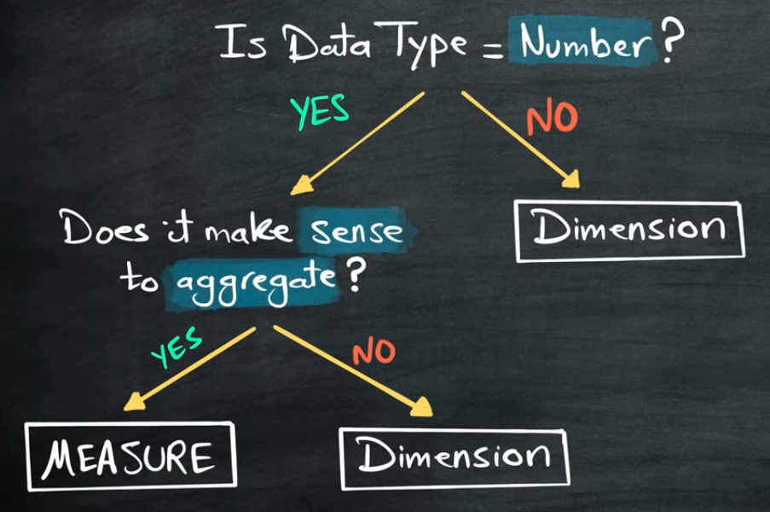

According to our table
Measure
- Sales
- Quantity
- Age

Dimensions
- Category
- Product
- Birthdate
- Customer ID

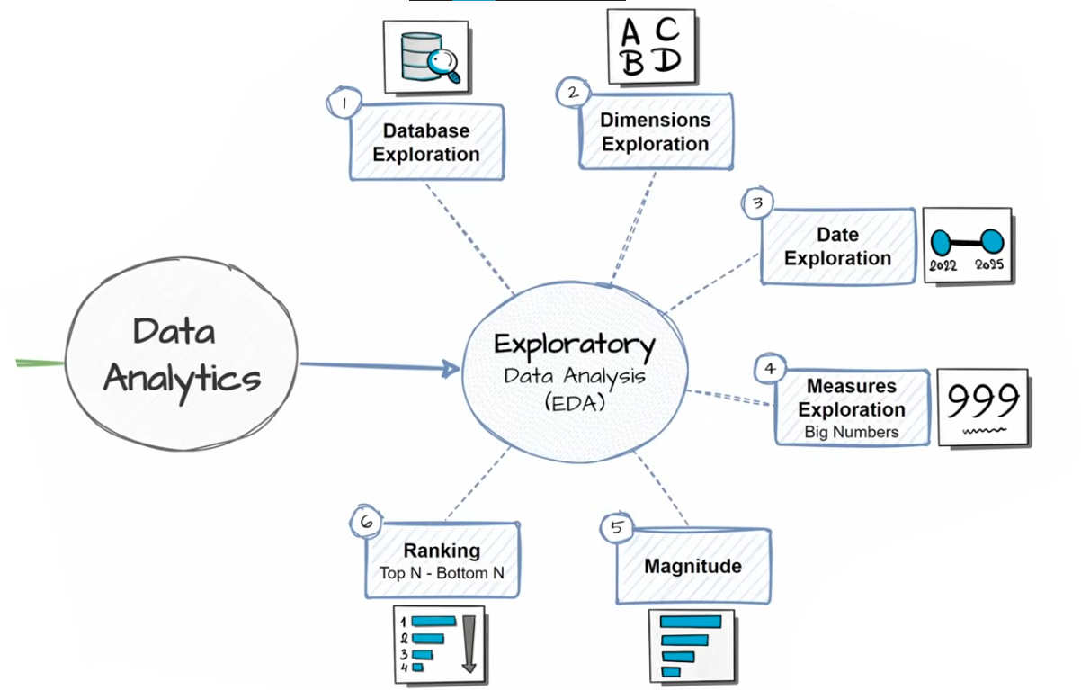
Dimensions Exploration
Identifying the unique values (or categories) in each dimension.
Recognizing how data might be grouped or segmented, which is useful for later analysis.

Date Exploration
Identify the earliest and latest dates (boundaries). Understand the scope of data and timespan.

Measures Exploration
Calculate the key metric of the business (Big Numbers)
- Highest Level of Aggregation | Lowest Level of Details

Magnitude Analysis
Compare the measure values by categories. It helps us understand the importance of different categories the formula for that is $\sum{\left[Measure\right] BY [ Dimension]}$
Example:
- Total sales by country
- Total Quantity by category
- Average price by product
- Total orders by customers

Ranking Analysis
Order the values of dimensions by measure. Top N performers | Bottom N performers $RANK\left[Dimensions\right] BY \sum{\left[Measure\right]}$
Example:
- Rank countries by total sales
- Top 5 products by quantity
- Bottom 3 customers by total orders

